Contents
1. Viewing Pay Codes 2
1.1. Search by Pay Code 2
1.2. Search by description or partial description 2
1.3. Search using the Advanced Filter 2
1.4. Pay Code Details 3
1.5. Viewing Court/Voluntary Order pay codes 5
2. Creating New Pay Codes 5
2.1. Creating a New Pay Code 5
2.2. Copying an Existing Pay Code 6
2.3. Pay Code Formula 7
2.4. Rules (adding/editing a rule) 9
2.5. Rules (removing an existing rule) 12
2.6. General Ledger Details 12
2.7. Create the Retrospection Pay Code 13
2.8. Court Orders 14
3. Editing Existing Pay Codes 15

Knowledge Article: Pay Codes (Allowances & Deductions)

Reports

Some reports have pay codes hard-coded into calculations and conditions. Payroll should confirm whether a pay code needs to be added to any of the following reports.

If the pay code is for an allowance administered by departments, you must add it to the ALLOWANCE_FLAG calculation in the following .RDL files:
- PERDEP01 Full Data Set
- PERDEP01 Full Data Set with Allowances
- PERDEP20 Approved Allowance Changes

If the pay code is for Linacre College, you must add it to the calculations and/or conditions for:
- PAYLIN20 Linacre College Detailed Salary
- PAYLIN21 Linacre College Summary Salary

If the pay code will be used to record Hourly Rates for Casual Payroll processing, you must add it to the conditions for:
- PAYCTR40 Casual Hours Monitoring Report

This is not an exhaustive list; there may be other reports we have not yet identified.

Other related documents

The Pay Code List, a reference resource used by HRIS Support.
The New Pay Code Request Template, which must be completed by Payroll whenever a new pay code is required.
Completed pay code requests can be found under: P:\PROJECTS\HRIS Programme\12. Support\Reference Data\Pay codes

Viewing Pay Codes

Core|Portal > Payroll Dashboard > Settings > Codes > Pay Codes

The Pay Code Library will open: | 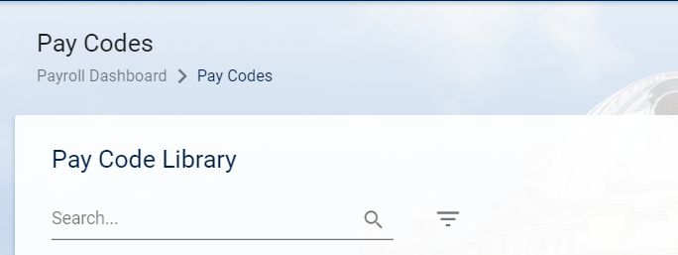

Search by Pay Code
- Enter the pay code you wish to view and click on the magnifying glass to search: | 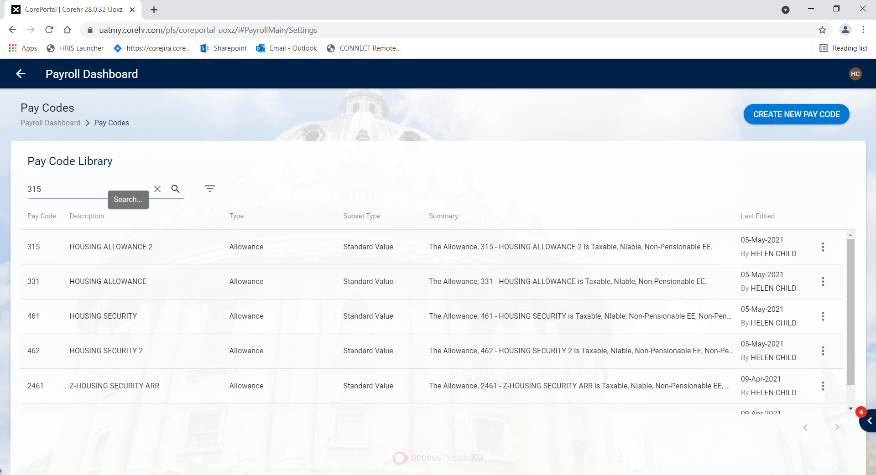

Search by description or partial description

    - Enter the full or partial description of the pay code you wish to view and click on the magnifying glass to search:
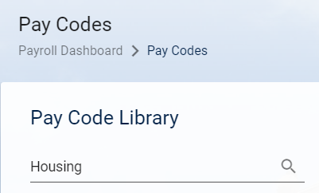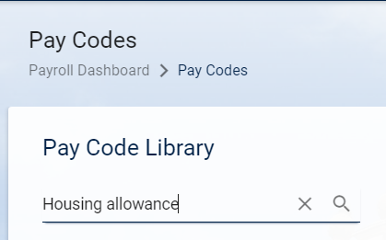

Search using the Advanced Filter

- Click on the filter  and choose a payment type: | 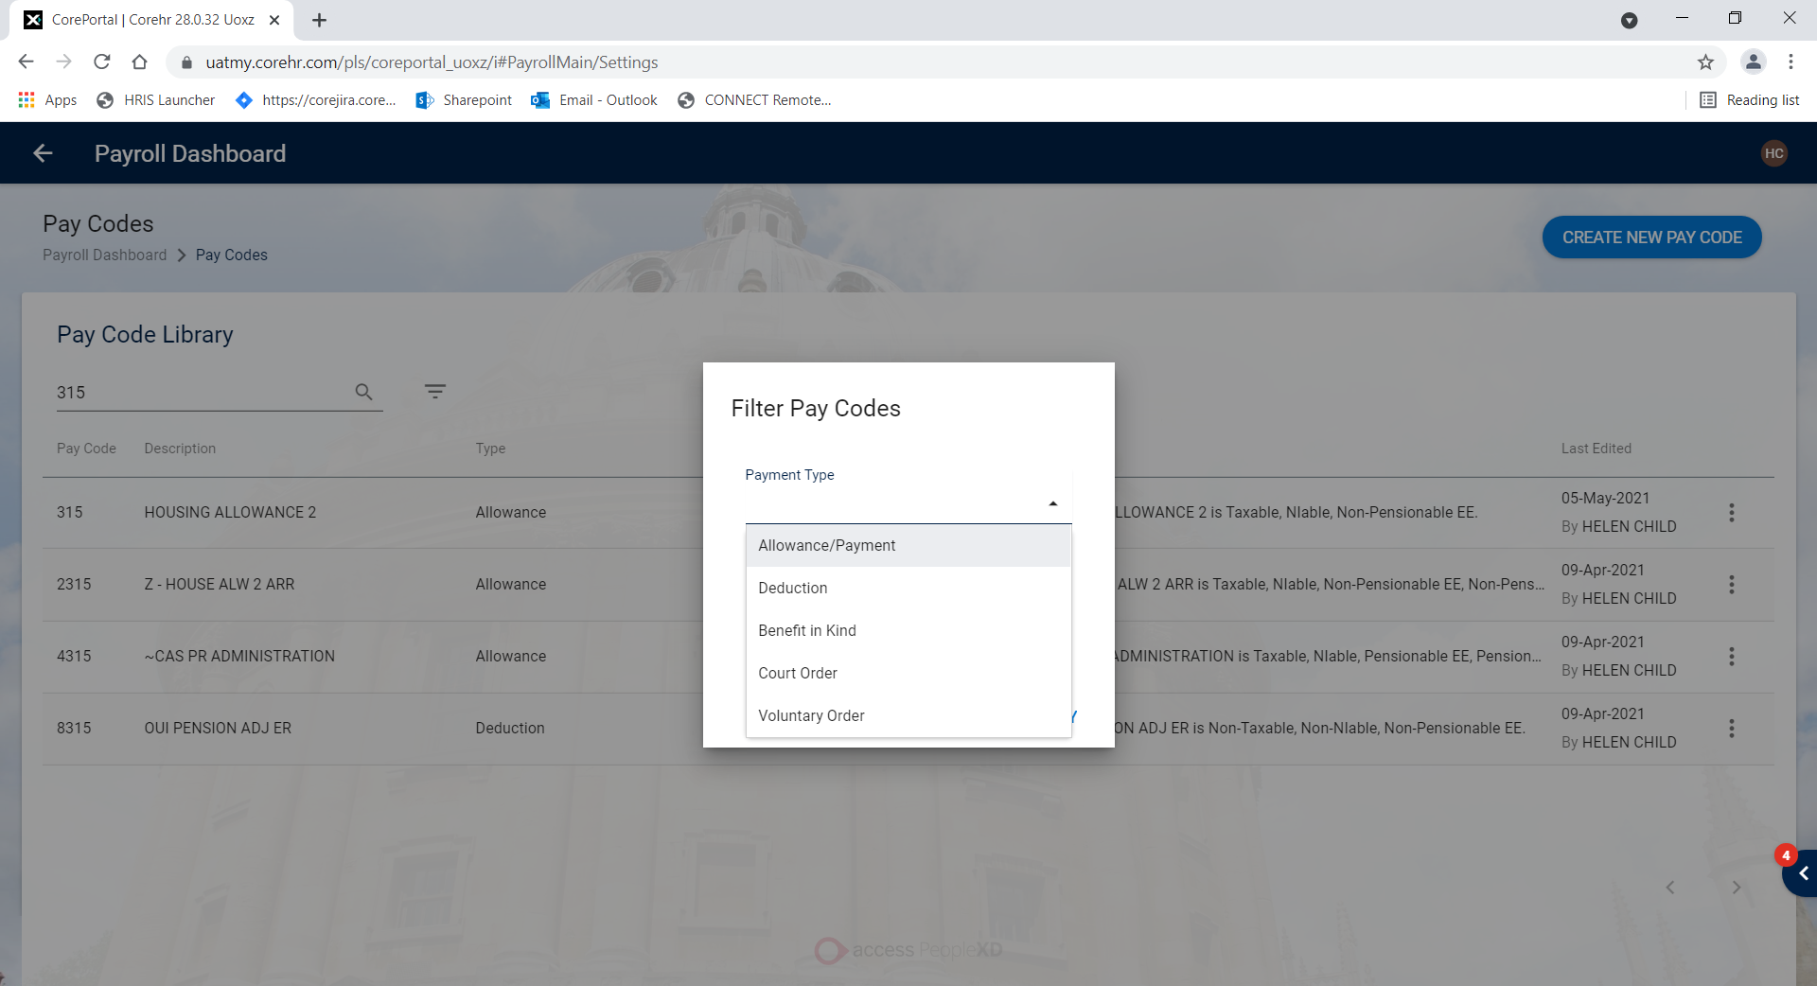

Pay Code Details

    - Click on the ellipses (…) next to the pay code you wish to view and choose Edit

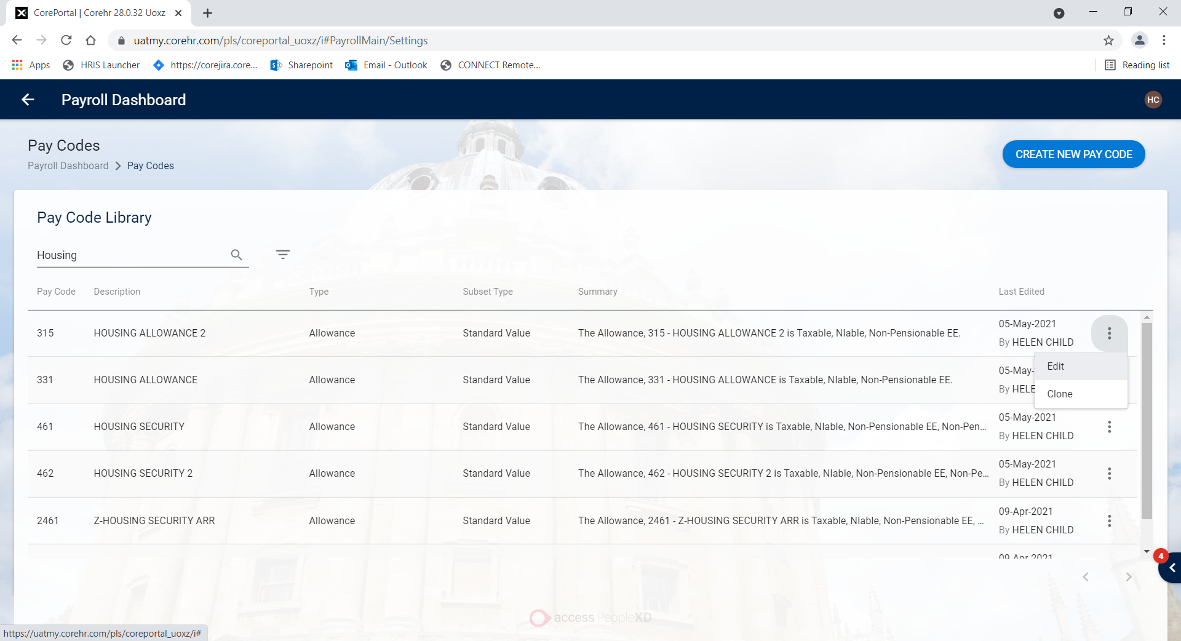

- In the Portal there is a new Pay Code Wizard which is usually made up of three sections (see section 1.5 for exceptions):  1 - Pay Code Formula  2 - Rules  3 - General Ledger  These can be used to navigate between the tabs | 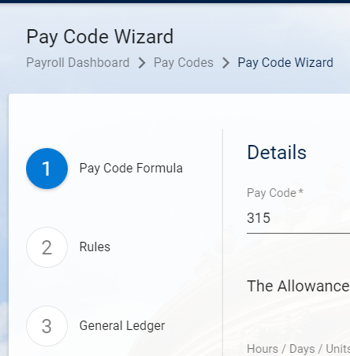

1 - Pay Code Formula is for the basic setup of the pay code.

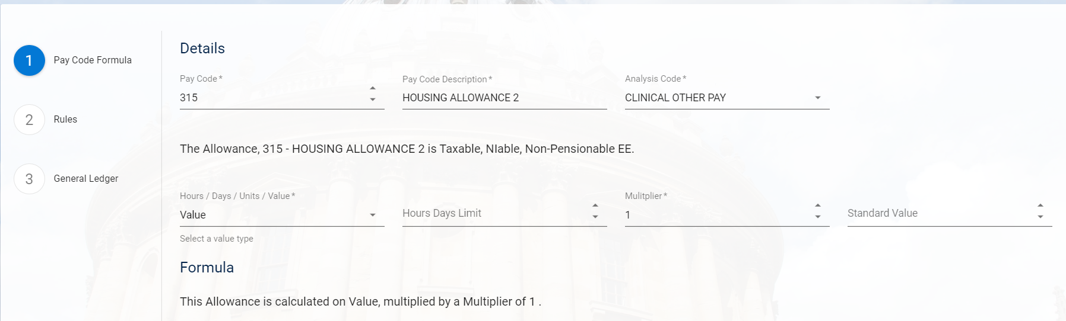

 | NB1: Different fields will appear in the Pay Code Formula screen depending on the type of pay code being viewed e.g. allowance, deduction, percentage, scaled.  NB2: Percentage allowances will include options for maintaining elements linked to the Pay code

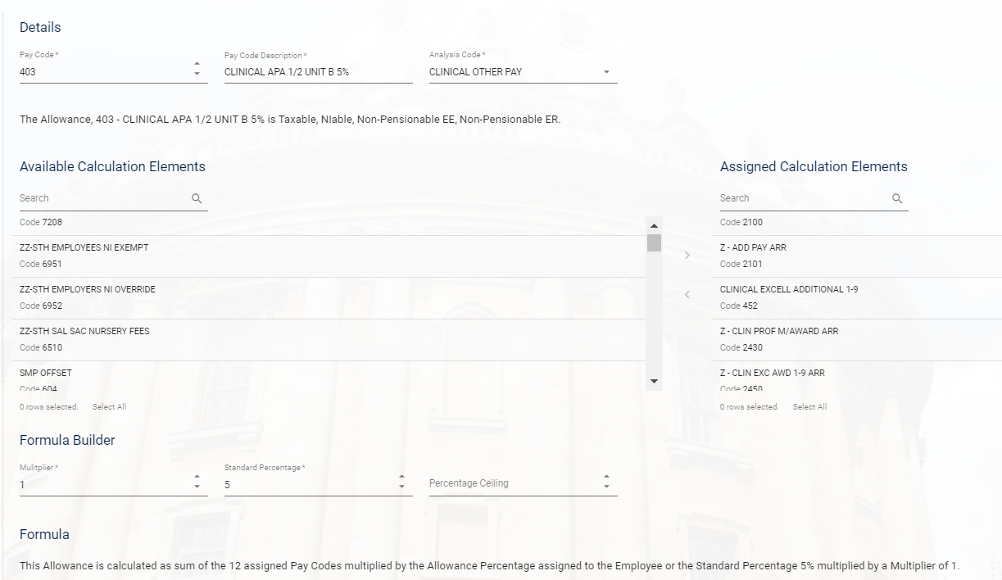

This tab includes a summary of the allowance details:

And a summary of the basis for calculating the allowance or deduction:

2 - Rules is where all the detailed configuration is made, e.g. whether the pay code is taxable, Ni’able, pensionable etc:

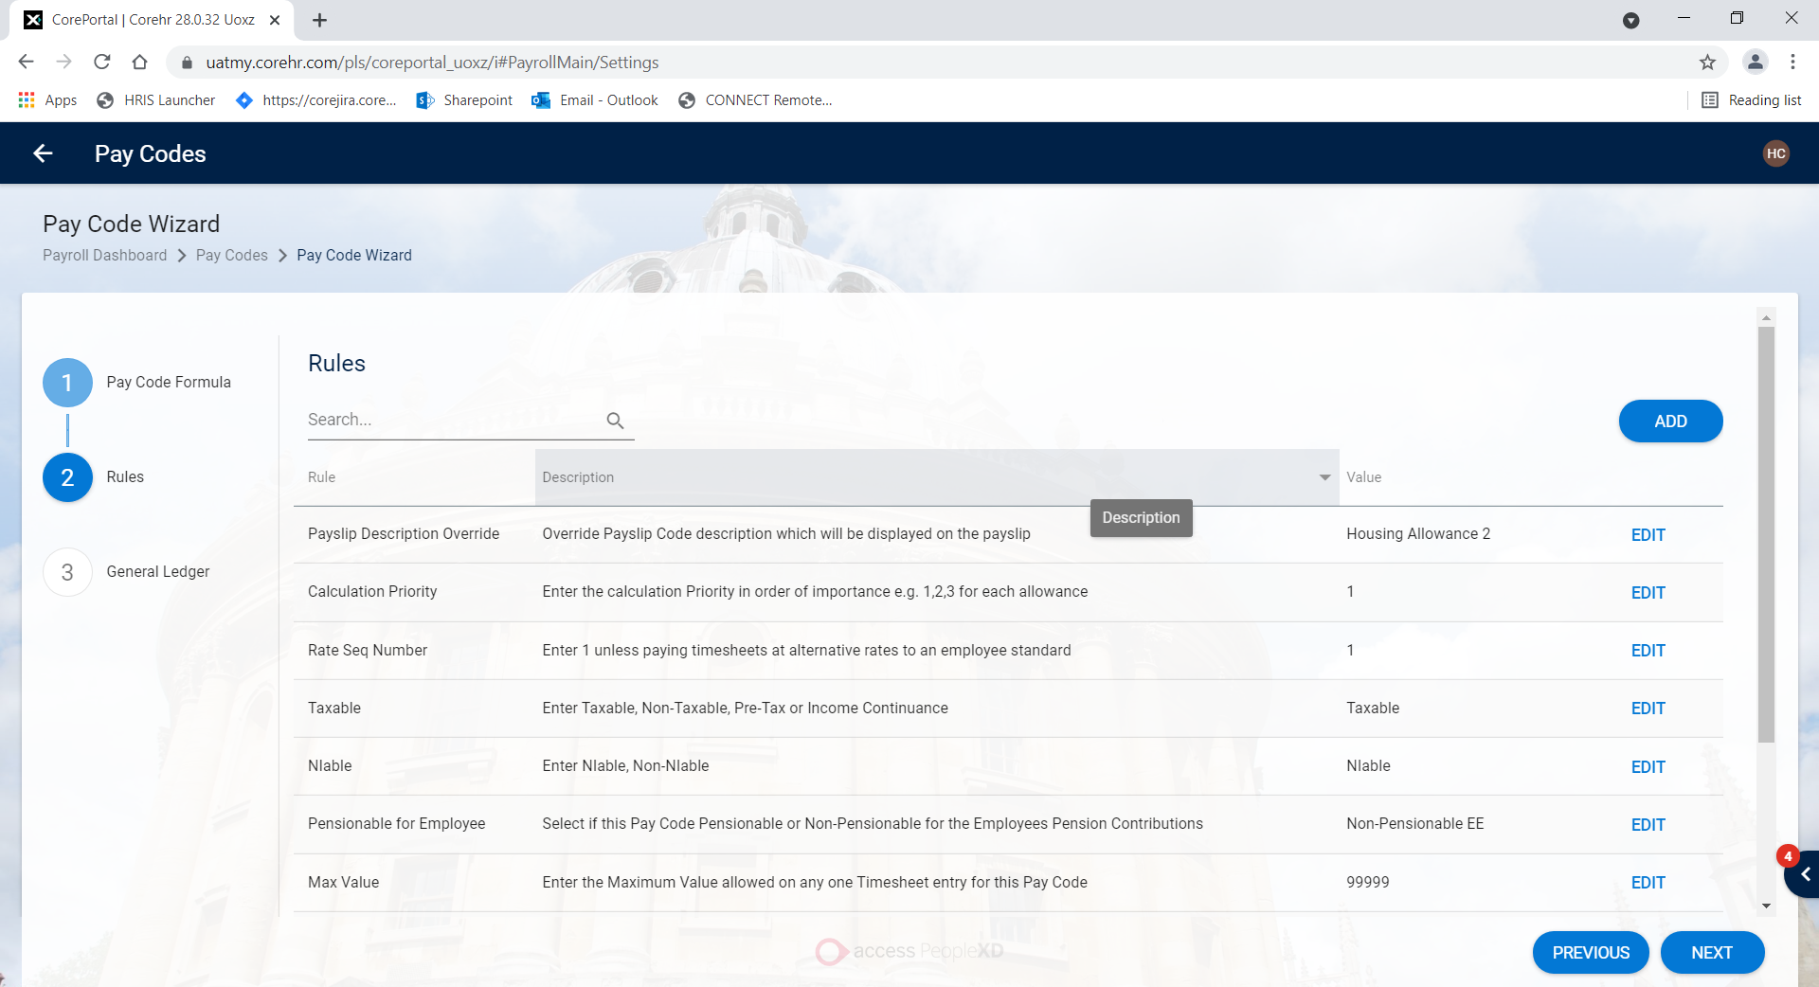

3 - General Ledger is where all the finance related configuration is made, e.g. the Expense code associated with the pay code

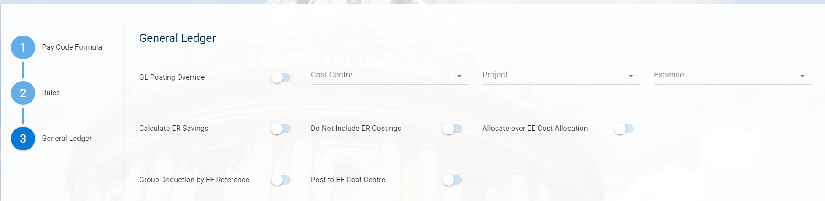

Viewing Court/Voluntary Order pay codes

    - If a pay code relates to a Court Order or Voluntary Order, the wizard has four tabs/sections:

1 - Pay Code Formula  2 - Payment Orders  3 - Rules  4 - General Ledger  These can be used to navigate between the tabs.  *All other details remain as described in the above steps | 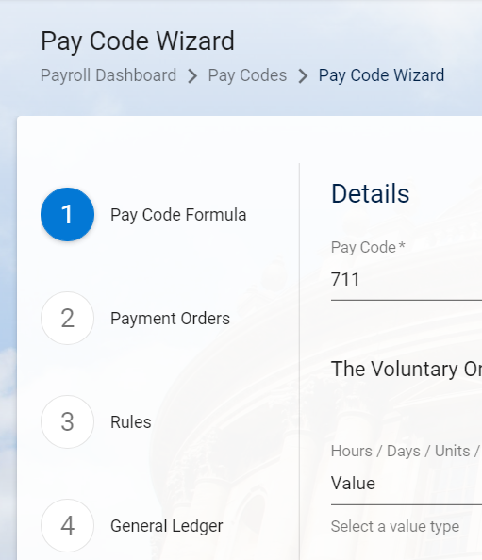

Creating New Pay Codes
 | NB: Payroll must complete a New Pay Code Request spreadsheet whenever they require a new pay code. Refer to this spreadsheet in order to complete the steps below.

Core|Portal > Payroll Dashboard > Settings > Codes > Pay Codes

The Pay Code Library will open:

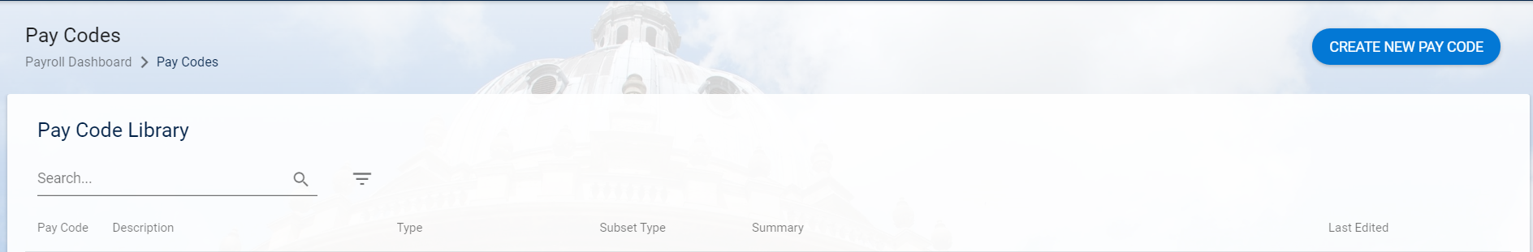

Creating a New Pay Code

In most cases a new pay code will be created by copying an existing pay code. However if you need to create a brand new pay code click on CREATE NEW PAY CODE.

- The Create New Pay Code pop up window will appear * | 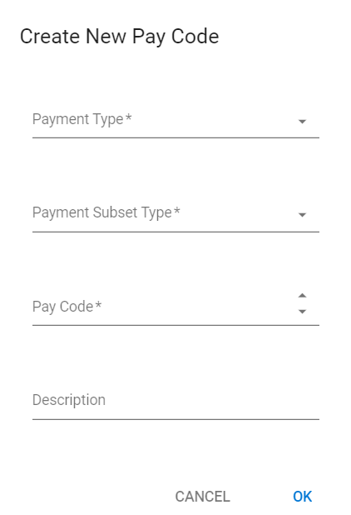
- Select the Payment Type *  NB: once the pay code has been saved you cannot edit the Payment Type. | 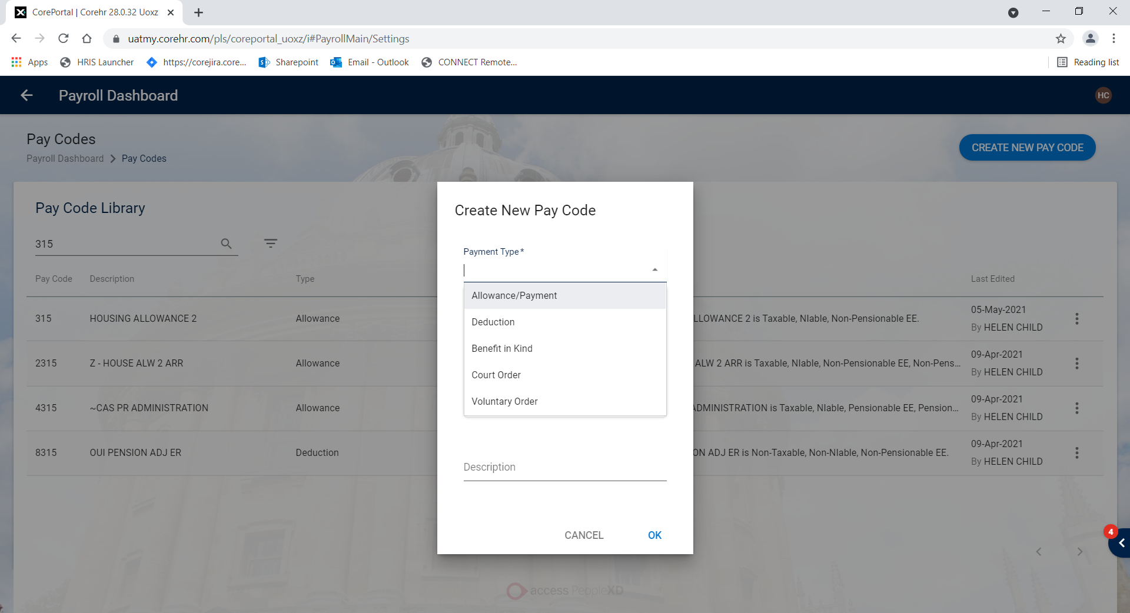
- Select the Payment Subset Type * | 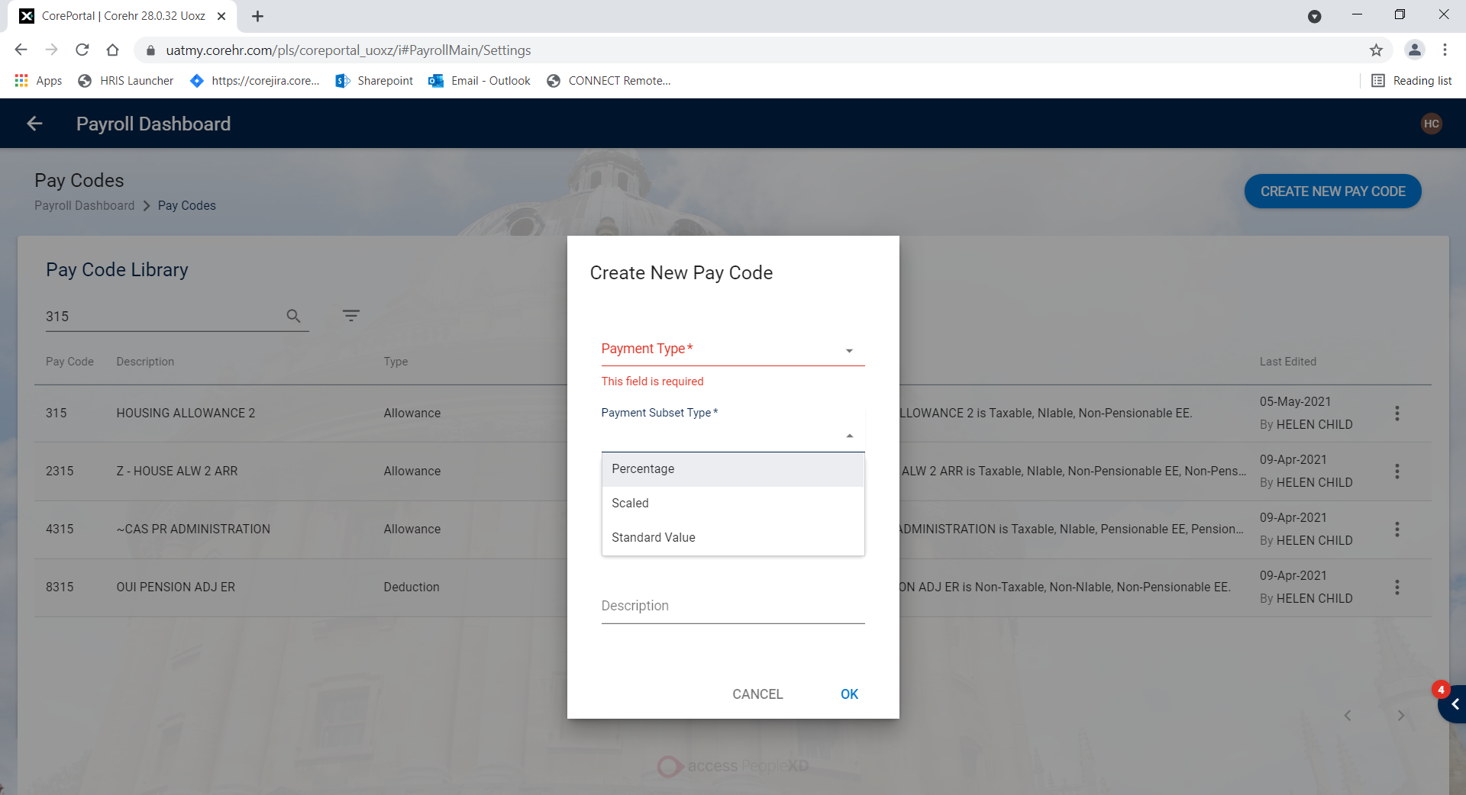

    - To complete the pay code setup follow the steps from 2.3 onwards

Copying an Existing Pay Code
- Open the New Pay Code Request spreadsheet Payroll have provided and refer to “Copy Pay code” column: | 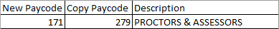
- Search for the pay code you wish to copy: | 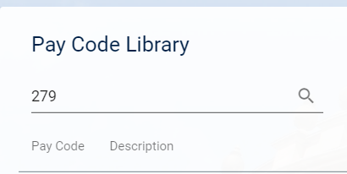

    - Click on the ellipses (…) against the pay code and click on Clone.

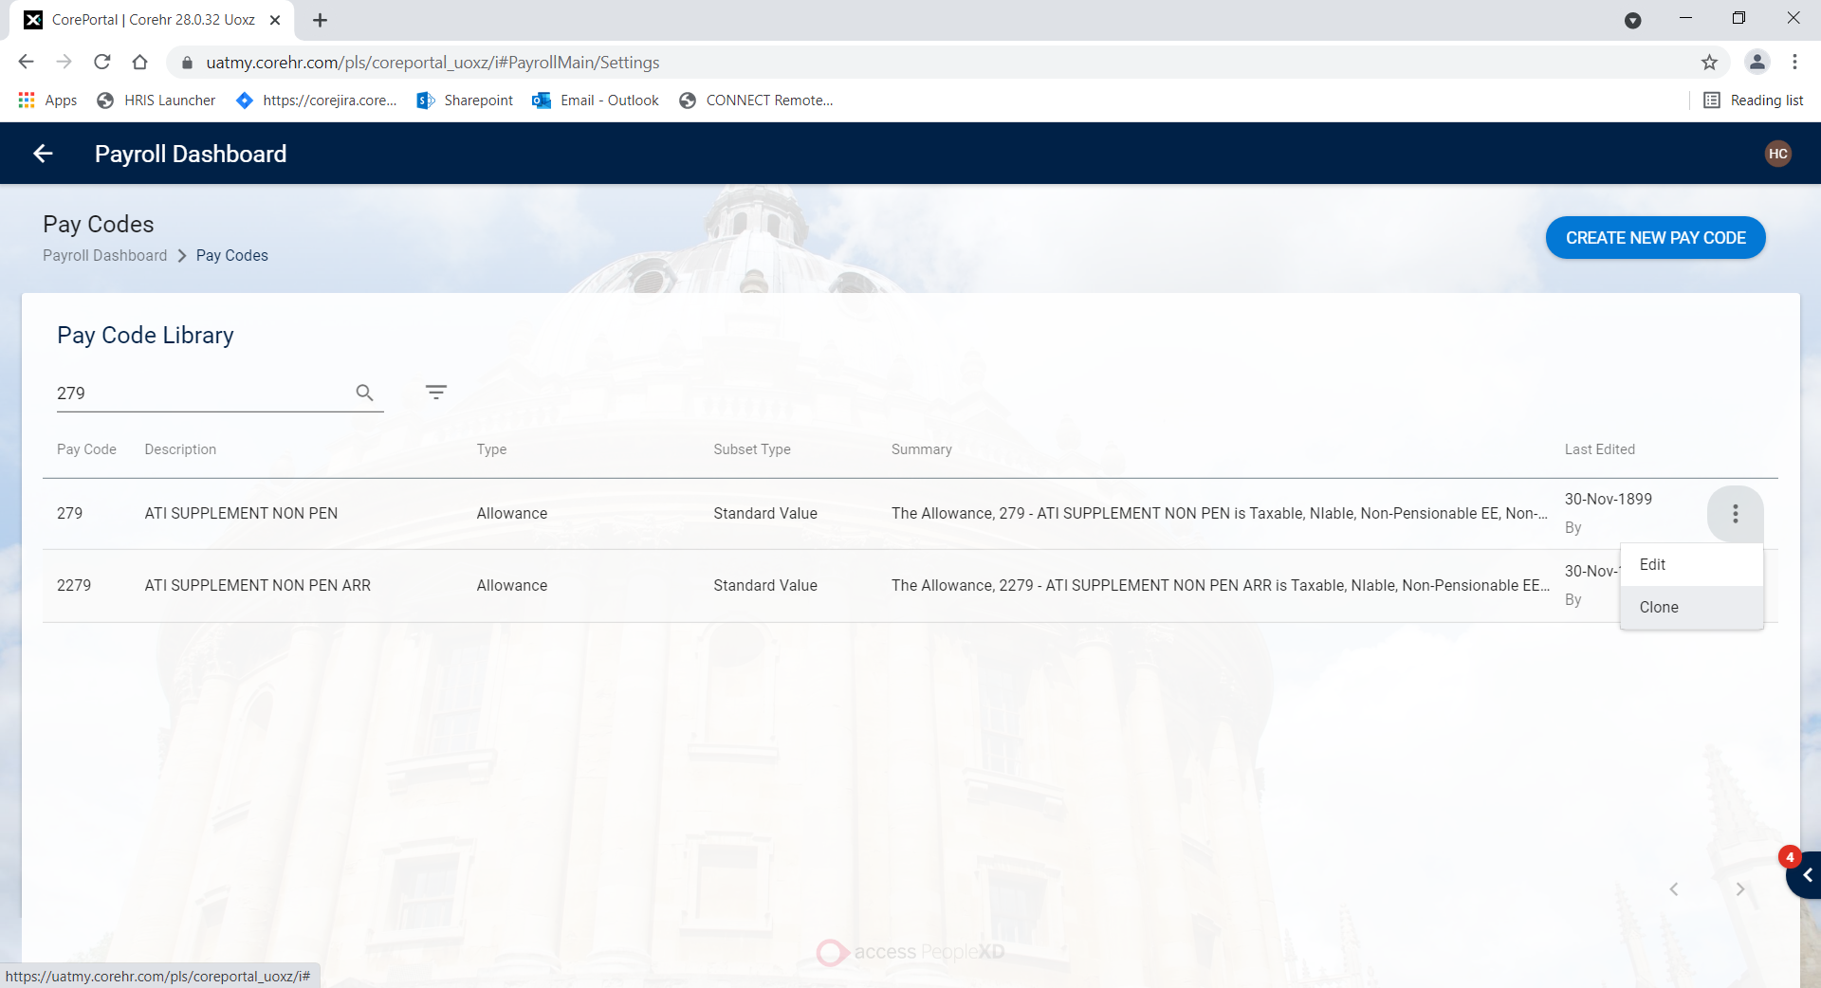

- The Copy Pay Code window will open confirming the pay code being copied. | 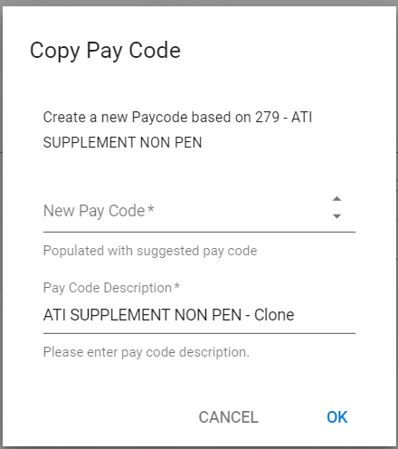
- Enter the Code and Description from the New Pay Code Request spreadsheet payroll provided  - Click OK. | 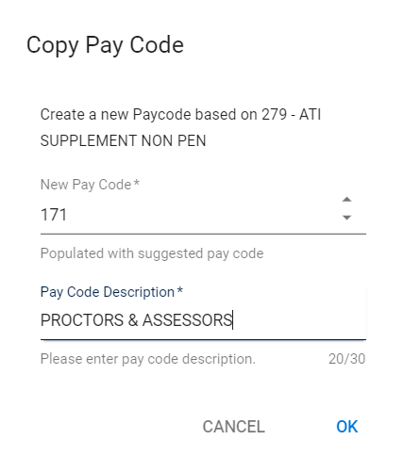

Pay Code Formula
If you cloned a pay code some attributes and settings may already be present as they will have been copied from the original pay code. You should always check and update if necessary.

    - Refer to the information in the relevant section of the New Pay Code Request spreadsheet, and use it to update/check the fields on the new pay code:

Field Name (*mandatory) | Description
Analysis Code* | Use the value provided in the New Pay Code Request spreadsheet.
Hours/Value/Days/Units* | Hours - for hourly rates  Value - for amounts and percentages  Days – for daily rate (note this can only be used in conjunction with a set rate or a pay scale and point)  Units - not used at present, however could be used for set unit rates
Hours/Days Limit | Complete for Hours and Days pay codes only.
Multiplier* | Enter the relevant value from this list:  0 for pay codes which are not to be paid via Payroll  1 for a normal allowance  -1 for a negative allowance or deduction  1.5 for overtime  2 for double time
For some allowances/deductions, the following may also be required
Standard Value | Enter a value if one has been provided, otherwise leave blank.
Scaled Deduction | Add/update scales if provided, otherwise leave blank  [If you create a scaled deduction pay code, you will need to enter the thresholds – see image 1 below ]
Percentage  [Calculation Elements] | Search for the relevant pay code in the list:  [If you create a percentage pay code you will need to enter the pay codes from which the percentage is calculated]  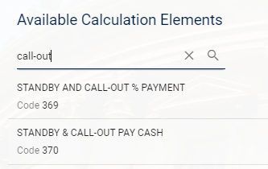
Standard Percentage | Enter a value if one has been provided, otherwise leave blank.
Percentage ceiling amount PCF | Enter a value if one has been provided, otherwise leave blank – not generally used.
Student Loan  [Thresholds] | If the Student Loan Rule is specified on the New Pay Code Request spreadsheet, you may need to add the thresholds (see image 1 below). [Payroll must provide details of the Thresholds in order for these to be set up.]

Image 1 Scaled deduction thresholds
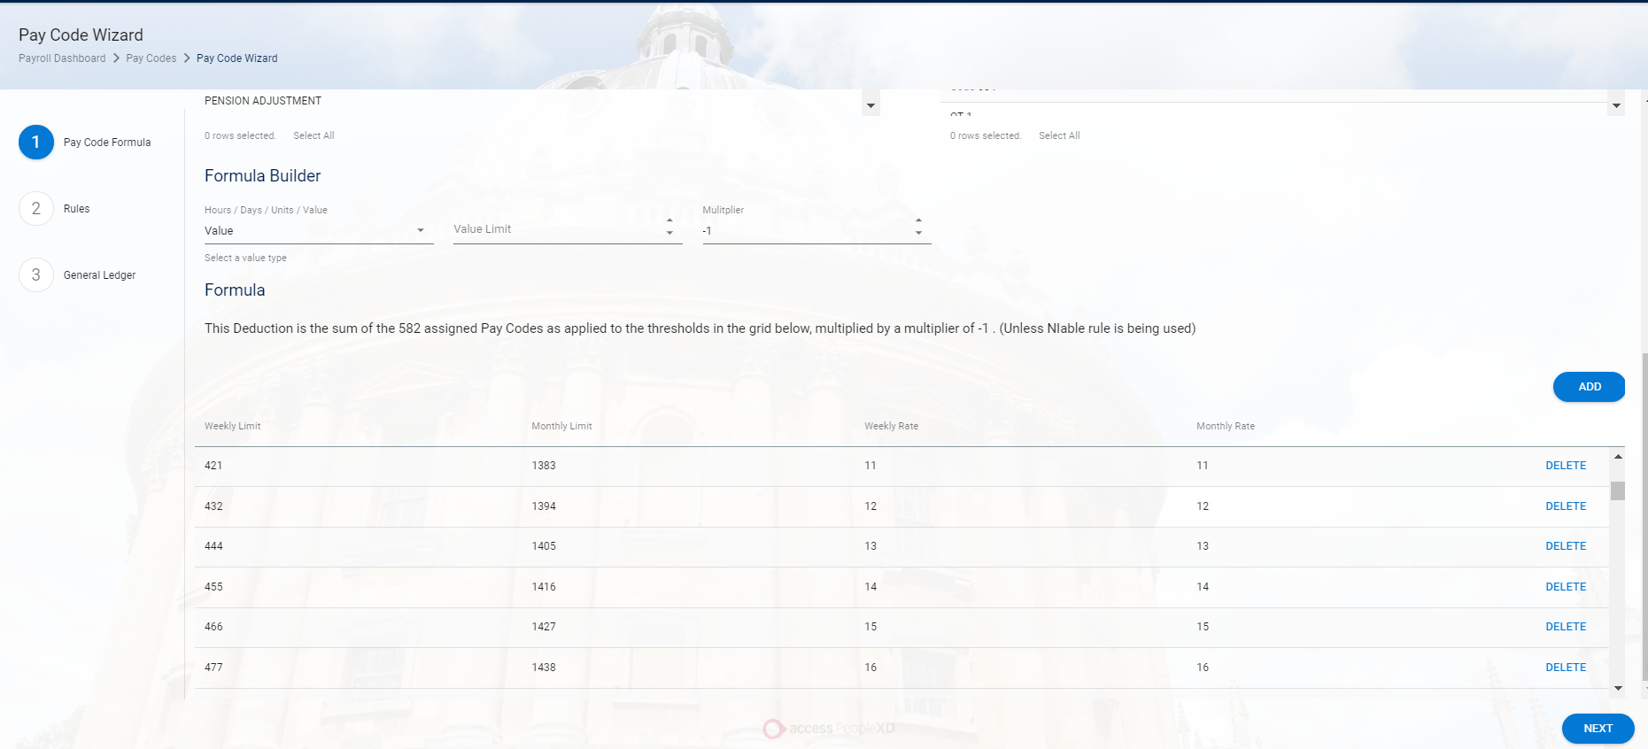

    - Click NEXT or 

Rules (adding/editing a rule)

    - To add a new rule click on ADD

- Scroll down the list or start typing the description to find the rule you wish to add  NB: If a rule has already been added, it will not be available to select in the drop-down list. | 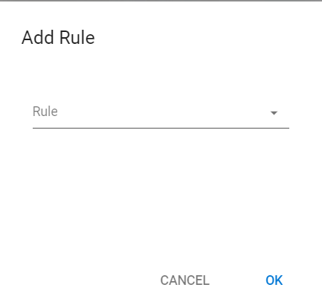
- When you select a rule, a brief description will be displayed | 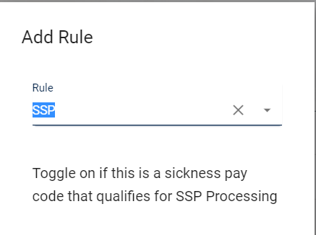
- Some rules have a toggle button to enable or disabled the rule. | 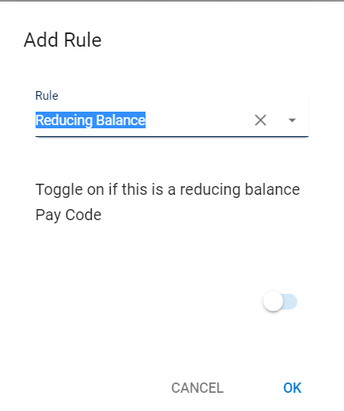
- Some have a drop-down list to choose from | 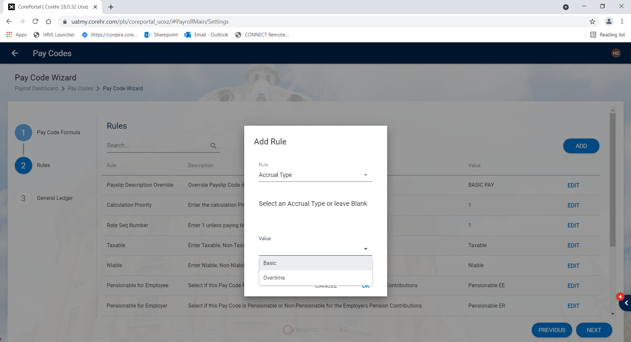

Refer to the information in the relevant section of the New Pay Code Request spreadsheet.

 | Note: If a rule is already present and the value is different from the pay code you cloned, you will need to edit it.  If a rule is not already present you will need to add one following the steps from 2.4.1 above.  If a rule is present but is not applicable for the new pay code you will need to delete it following the steps in 2.5

Field Name (*mandatory) | Description
Taxable* | Select the relevant value from the list: Taxable, Non-Taxable, Pre-Taxable, Income Continuance.
NIable* | Select the relevant value from the list: NIable, Non-NIable.
Deduction/Allowance/BIK | This cannot be edited if a Pay Code has been cloned.
Pensionable EE | Use the value provided in the New Pay Code Request spreadsheet.
Pensionable ER | Use the value provided in the New Pay Code Request spreadsheet.
Disable for Allowances/Deductions | Use the value provided in the New Pay Code Request spreadsheet.
Disable for Timesheets | Use the value provided in the New Pay Code Request spreadsheet.
Maximum value | 99999.00
Minimum Value | -99999.00
Retrospection Pay Code | Use the value provided in the New Pay Code Request spreadsheet.  Steps to create a new retro pay code are in section 2.7
Payslip Code Override | Use the value provided in the New Pay Code Request spreadsheet.
Payslip Description Override | Use the value provided in the New Pay Code Request spreadsheet.
Labour Cost Group | N/A
For some allowances/deductions the following may also be required
Student Loan | Add the rule if indicated on the New Pay Code Request.
Calculation Priority | Add the rule if indicated on the New Pay Code Request.
Pro Rata Indicator | Add the rule if indicated on the New Pay Code Request.
Pro Rata Element | Add the rule if indicated on the New Pay Code Request.
Pro Rata Calculation | Add the rule if indicated on the New Pay Code Request.
Reducing Balance | Add the rule if indicated on the New Pay Code Request.
Acting Up | Add the rule if indicated on the New Pay Code Request.
Pay in Full | Add the rule if indicated on the New Pay Code Request.
Scaled Rounding Method | Add the rule if indicated on the New Pay Code Request.
Calculation Priority | Add the rule if indicated on the New Pay Code Request.
OAP Adjustment Ind. | Add the rule if indicated on the New Pay Code Request.
Reducing Balance | Add the rule if indicated on the New Pay Code Request.
Spreadable Deduction | Add the rule if indicated on the New Pay Code Request.
Accumulate Unpaid | Add the rule if indicated on the New Pay Code Request.
Cumulative Deduction | Add the rule if indicated on the New Pay Code Request.
No. of Dedn. Weeks | Add the rule if indicated on the New Pay Code Request.
Pro Rata Deduction | Add the rule if indicated on the New Pay Code Request.
Instalment Deduction | Add the rule if indicated on the New Pay Code Request.
Periodic Maximum | Add the rule if indicated on the New Pay Code Request.
No. of Dedn. Months | Add the rule if indicated on the New Pay Code Request.
RTI Statutory Deduction | Add the rule if indicated on the New Pay Code Request.
Annual Max. | Add the rule if indicated on the New Pay Code Request.
Timesheet Override | Add the rule if indicated on the New Pay Code Request.
    - Select and update the rule you wish to add and Click OK

 | NB: Once a rule has been added to a pay code, it will be displayed in the Rules tab

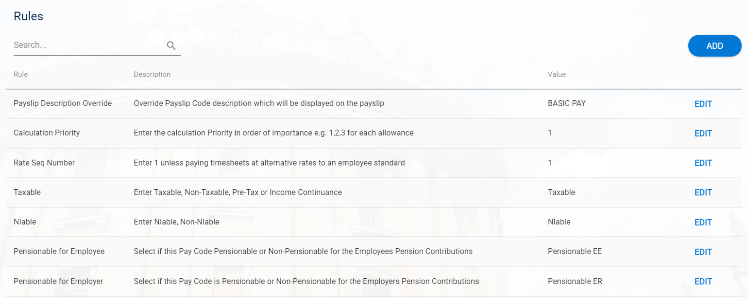

Rules (removing an existing rule)

- Click on EDIT  - Click on the cross to delete the rule then click OK  - Click NEXT | 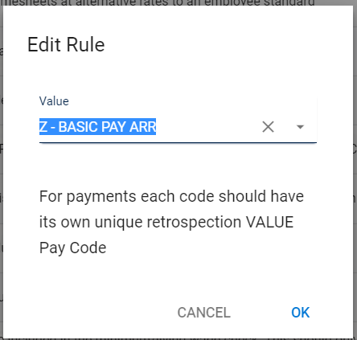

At the time of writing there is a bug that means the rule is not automatically displayed in the Edit Rule window. You need to search for it first as if you are going to add it and then click the cross to delete. This is temporary and it will be fixed in a future release.

General Ledger Details

    - Refer to the information in the relevant section of the New Pay Code Request spreadsheet, and use it to update/check the fields on the new pay code:

Field Name (*mandatory) | Description
GL Posting Override | Enable if specified on the New Pay Code Request.    This functionality will only work if used in conjunction with the ‘Allocate over Employer Cost Allocations’ flag.
Cost Centre | Enter a value if one has been provided, otherwise leave blank.
Project | N/A
Expense | Enter a value if one has been provided, otherwise leave blank.
Calculate ER Savings | Enable if specified on the New Pay Code Request.
Do not Include in ER Costings | N/A
Allocate over EE Cost Allocation | Enable if specified on the New Pay Code Request.  Can be used with the GL Posting Override flag (see above) or on its own to spread the cost according to the Cost Allocations in place for the employee.
Group Deduction by EE Reference | Enable if specified on the New Pay Code Request.
Post to EE Cost Centre | Enable if specified on the New Pay Code Request.

    - Click on SAVE

 | 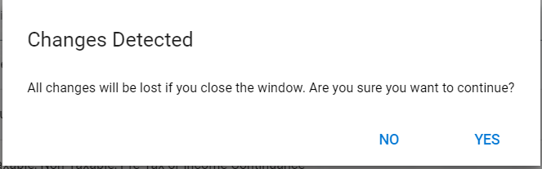  Note: The new pay code will not be saved until you have clicked SAVE on the General Ledger tab. If you attempt to exit at any time without saving, a warning message will appear.

Create the Retrospection Pay Code
 | NB: Once you finish entering details on the various tabs, you must go back to the General tab and add a retrospection pay code for the pay code you have just created.

    - Follow the steps in Section 2.2 to create the new retrospection pay code then return to this section to link the retro pay code to the main pay code

    - In Rules, click ADD and search for Retrospection Pay Code and click OK
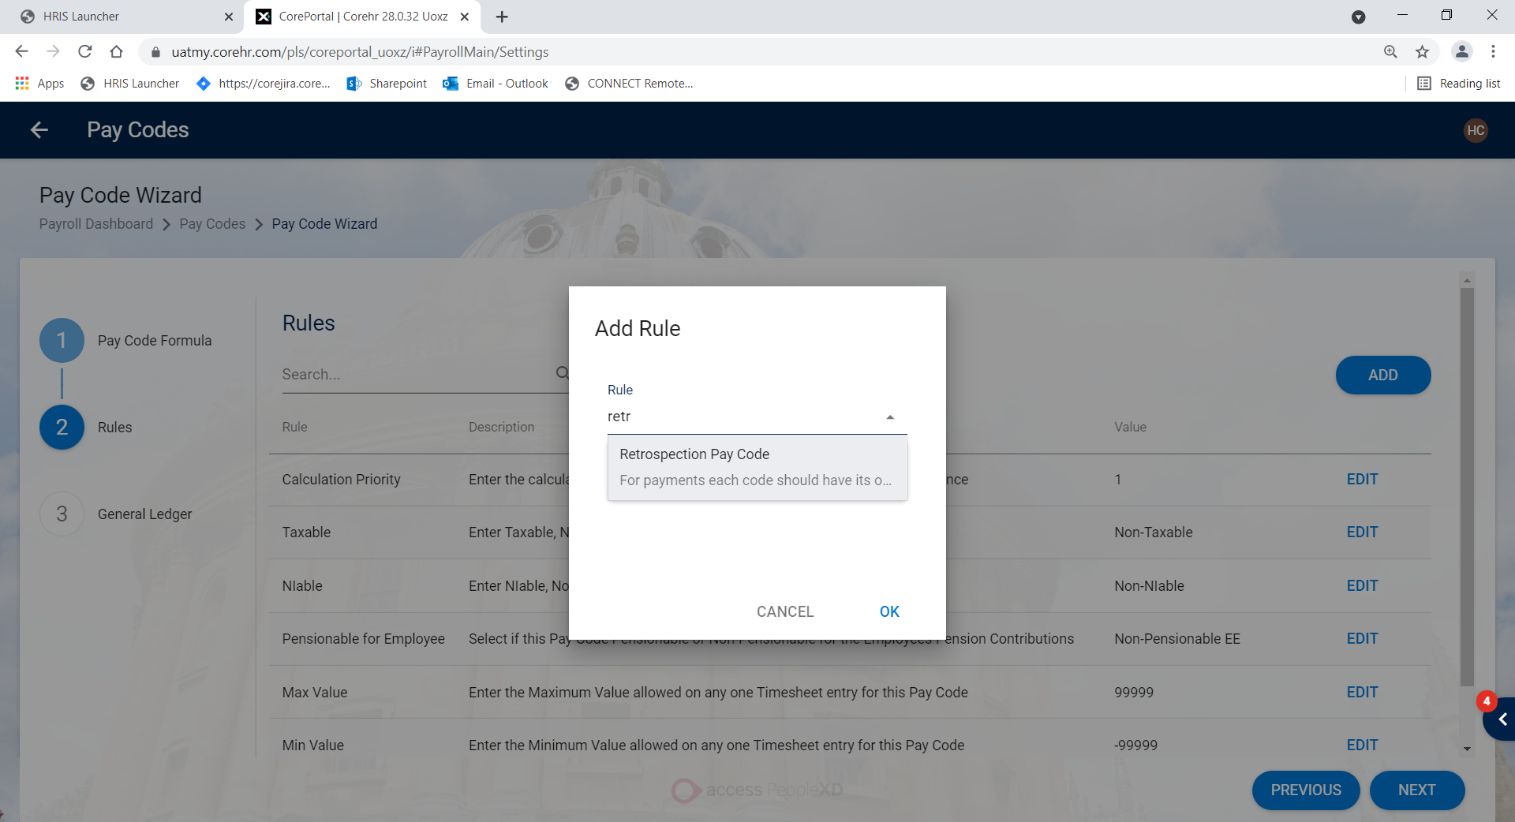 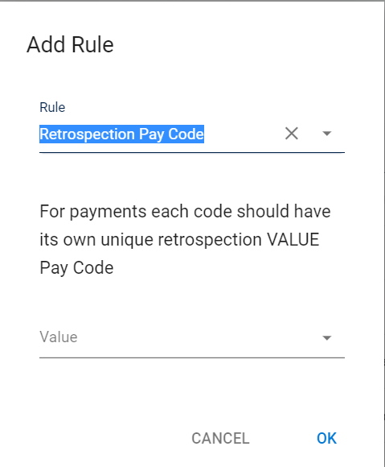

    - Enter the pay code you have just created in the Value field and click OK. The retrospection pay code you have added will be displayed in the Rules tab.

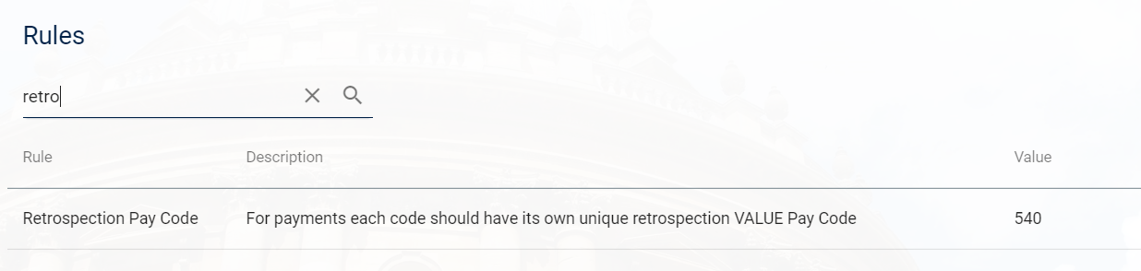

 | Note: If a code is already in use, it will not be available to select.

    - Click NEXT to navigate to the General Ledger tab and then SAVE

Court Orders

The following information is added on the Payment Orders tab. This tab is only displayed when the Pay Code type is Court Order or Voluntary Order.

Field Name (*mandatory) | Description
Court/Voluntary | Cannot be edited. This is specified at the time the pay code is created.
Admin Charge | Enter a value if one has been provided, otherwise leave blank.
Admin Code | Enter a value if one has been provided, otherwise leave blank.
Nett Earnings | Enable if specified on the New Pay Code Request spreadsheet.  [If you enable this field you will need to assign the rates. Payroll must provide details in order for these to be set up.]
AEO Code | Enable if specified on the New Pay Code Request spreadsheet.  [If you enable this field you will need to assign the calculation elements. Payroll must provide details in order for these to be set up.]
Scottish Arrestment Order | Enable if specified on the New Pay Code Request spreadsheet.
Protected Earnings Type | Enter a value if one has been provided, otherwise leave blank.
Protected Earnings %  [Percentage] | Enter a value if one has been provided, otherwise leave blank.  [Payroll must provide details of the Percentage in order for this to be set up.]

Editing Existing Pay Codes
Core|Portal > Payroll Dashboard > Settings > Codes > Pay Codes

The Pay Code Library will open:



- Search for the pay code you wish to edit: | 

    - Click on the ellipses (…) next to the pay code and choose Edit.

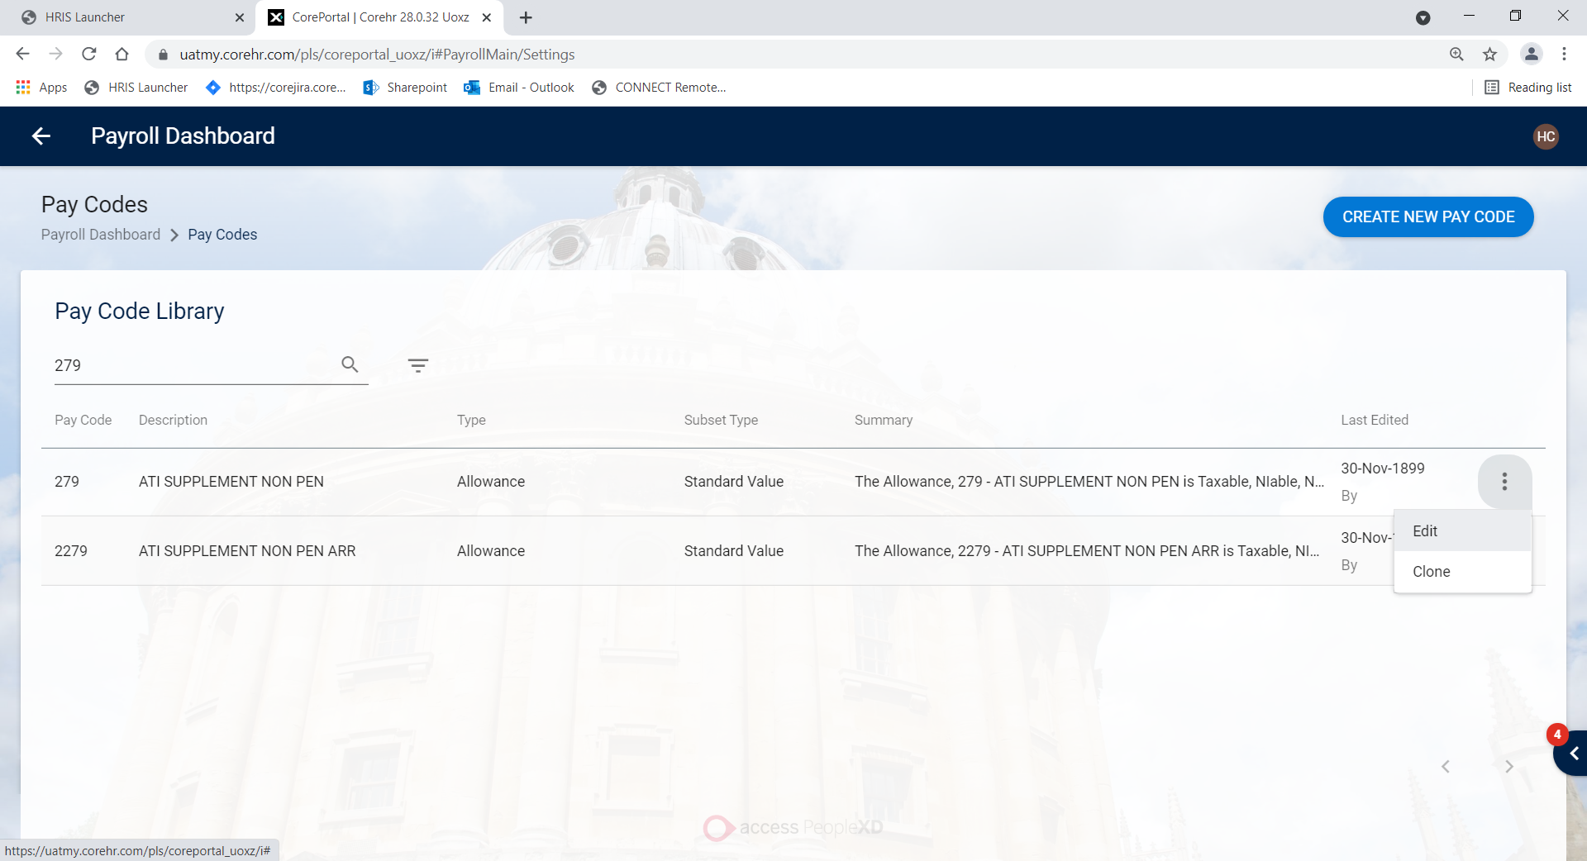

    - Edit as required.

